# Dublin Business School

# Assessment Brief

# Assessment Details

|  |  |
| --- | --- |
| Module Title: | Statistics for Data Analytics |
| Module Code: | B9DA101 |
| Module Leader: | Dr Shahram Azizi |
| Stage (if relevant): |  |
| Assessment Title: | CA two |
| Assessment Number (if relevant): |  |
| Assessment Type: |  |
| Restrictions on Time/Length : | Submission before deadline |
| Individual/Group: |  |
| Assessment Weighting: |  |
| Issue Date: |  |
| Hand In Date: | Before final exam |
| Planned Feedback Date: |  |
| Mode of Submission: | Online |

**Guideline:**

* This CA assesses students on core concept in Hypotheses tests, GLM analytics, and Bayesian analytics.
* All questions are mandatory.
* Use R/Rstudio to solve questions and perform analytics.
* Any submission after deadline will not be considered and scored.

**Question 1**

Consider a relational dataset and specify your input and output variables , then:

* 1. Train the model using 80% of this dataset and suggest an appropriate GLM to model **ouput** to **input** variables.

**(10 Marks)**

* 1. Specify the significant variables on the **output** variable at the level of 𝛼=0.05 and explore the related hypotheses test. Estimate the parameters of your model.

**(10 Marks)**

* 1. Predict the output of the test dataset using the trained model. Provide the functional form of the optimal predictive model.

**(10 Marks)**

* 1. Provide the confusion matrix and obtain the probability of correctness of predictions.

**(5 Marks)**

**(Total: 35 Marks)**

**Question 2**

Let $x_{1},…,x_{10}$ are identically independently distributed (iid) with Poisson($λ$).

1. Compute the likelihood function (LF**). (10 Marks)**

1. Adopt the appropriate conjugate prior to the parameter $λ$ (Hint: Choose hyperparameters optionally within the support of distribution). (**10 Marks)**
2. Using (a) and (b), find the posterior distribution of $λ$. **(10 Marks)**
3. Compute the minimum Bayesian risk estimator of $λ$. **(5 Marks)**

**(Total: 35 Marks)**

**Question 3**

An opinion poll surveyed a simple random sample of 1000 students. Respondents were classified by gender (male or female) and by opinion (Reservation for women, No Reservation, or No Opinion). Results are shown in the observed contingency table below.

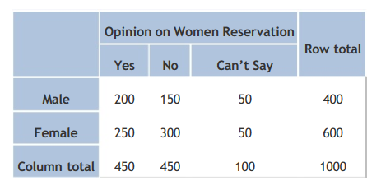

Does the gender and opinion on women reservation are independent? Use a 0.05 level of significance. To do so,

1. State the hypotheses. **(5 Marks)**
2. Find the statistic and critical values. **(10 Marks)**
3. Explain your decision and Interpret results. **(15 Marks)**

**(Total: 30 Marks)**